Domo
I had an awesome time at Nathans house this week
To start the week of we played chess and kicked his butt. 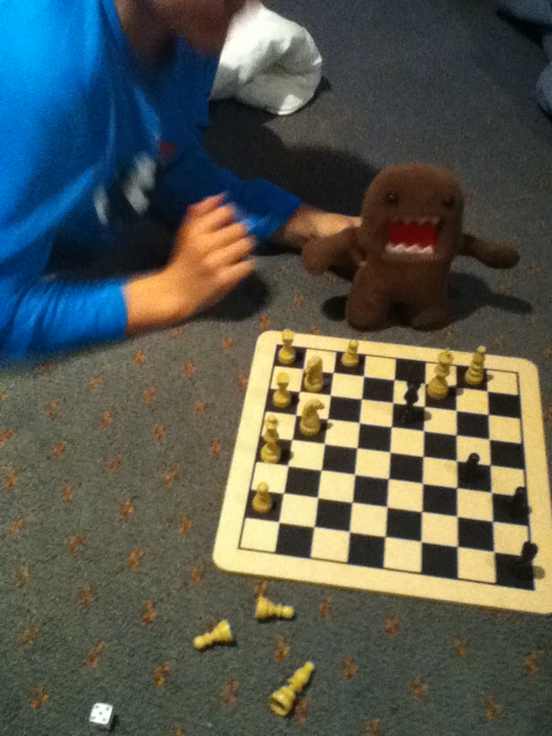

Then we went to the car show I broke into
one of the cars and broke it,

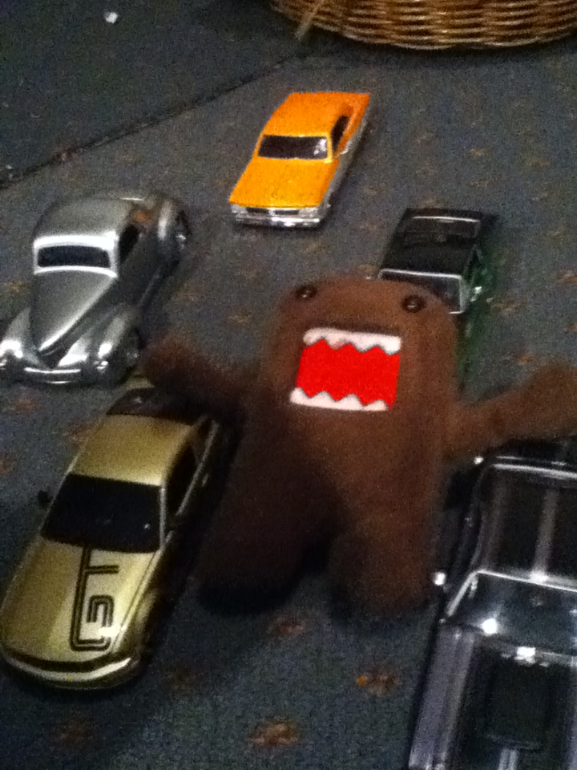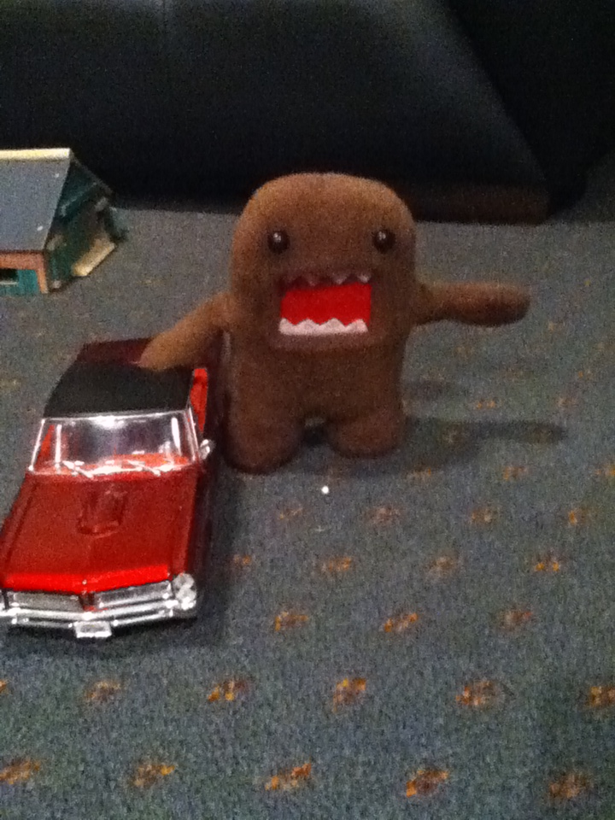

I ran and hid in the Bush, but the police caught me

and put him in the fire place I got my picture taken
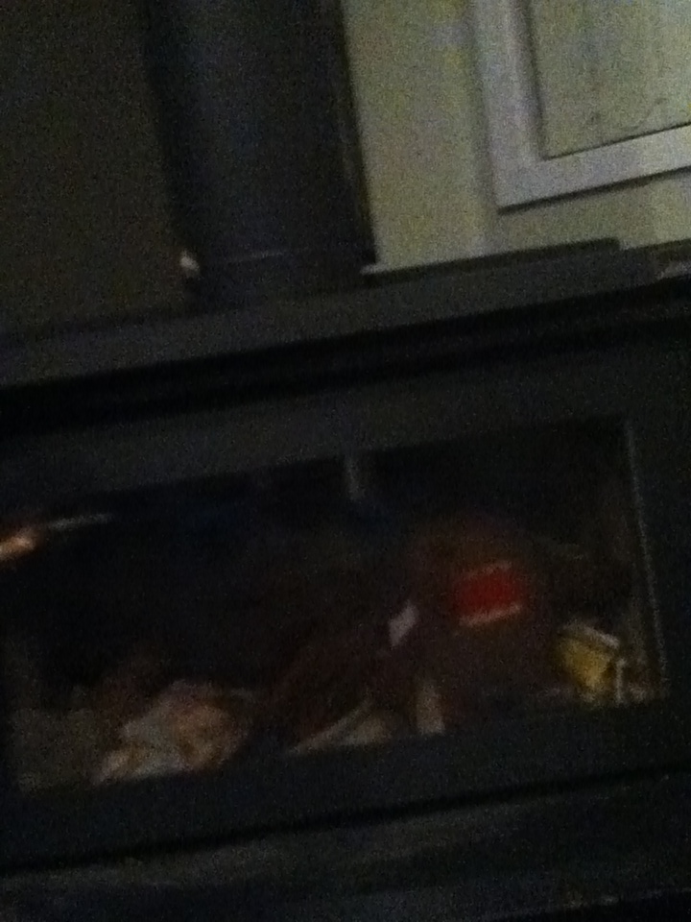
what a L.... I was sentenced to 100 hours community Service for the SPCA.
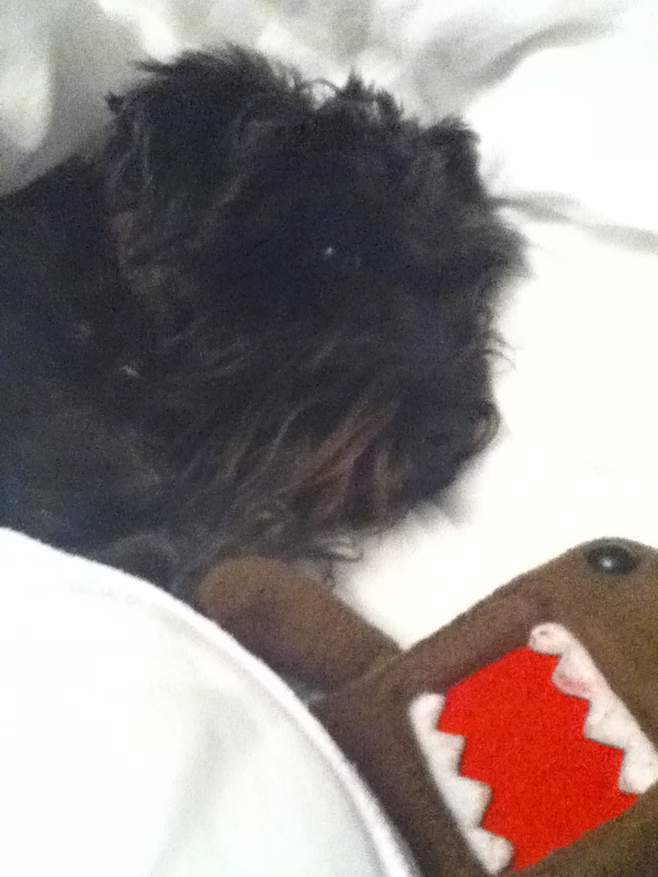

I had a good time with the dogs just lying around and that cat was a bit of a pest. Apart from being put in the fireplace I had a cool time at Nathans house.
