Te Hihi School
Years 4-6
Agricultural Day Project
2012
Kiwiana Letter Box
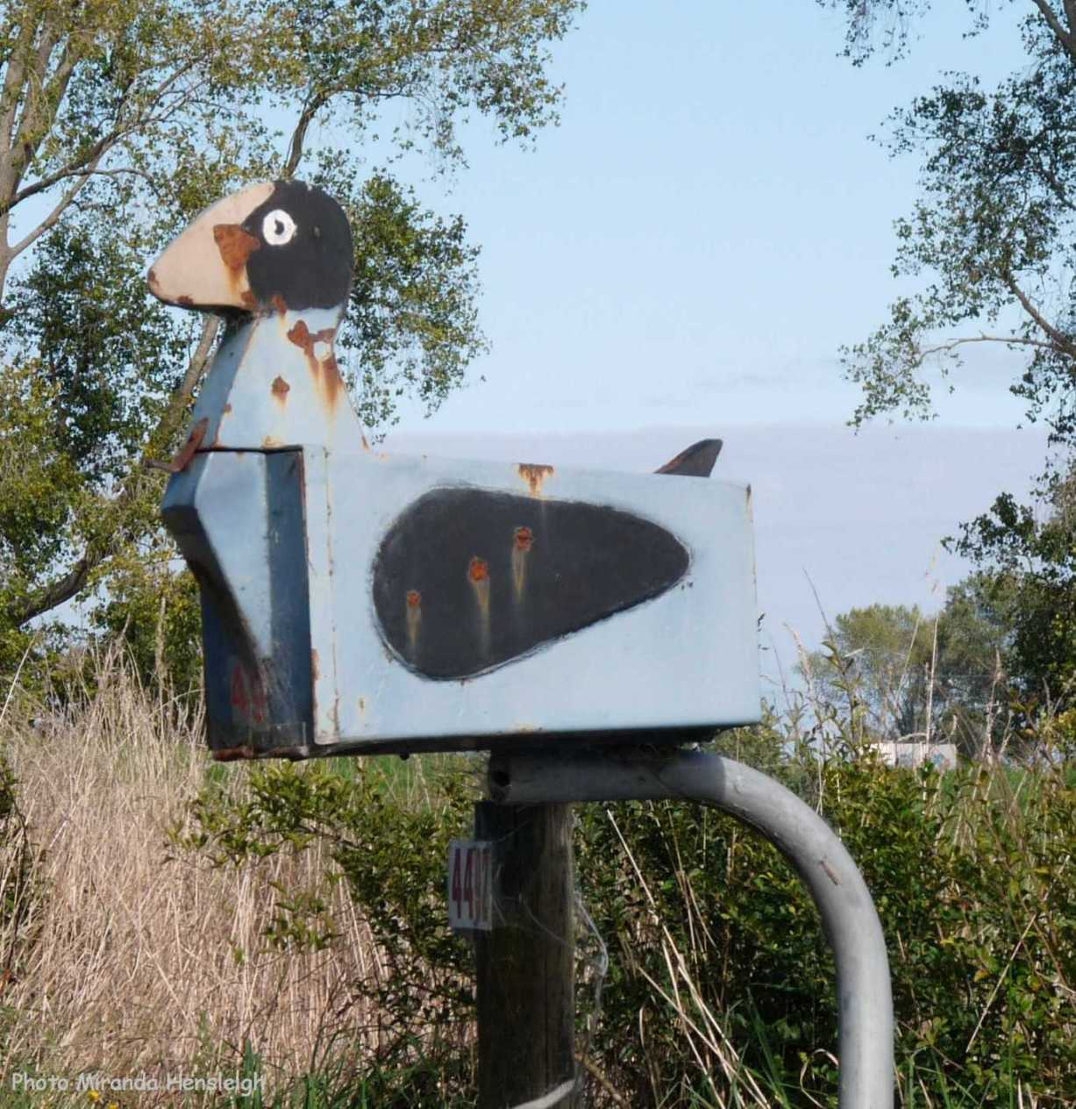

Research
Student Task
- Research the requirements of a letterbox in NZ (e.g height and positioning)
- Research what is ‘Kiwiana’ and how it represents NZ culture. Select 3 iconic Kiwiana symbols and give brief history.
- Design a letterbox on a stand.
The letterbox and stand must be made out of what would be considered to be durable materials that will withstand New Zealand conditions. There are lots of great ideas out there so the emphasis will be on innovation and function. You must use New Zealand culture as inspiration.
- Consider durability and what is able to withstand NZ weather conditions. Think Wood, corrugated iron, metal, plastic and exterior paint.

To help you with your research, here are some suggestions.
- Use books, School or Public Library and NZ post website.
- The internet (Try searching on Google images with the key words ‘kiwiana letterbox or ‘kiwiana art’ ‘New Zealand culture’ ‘letterbox requirements’)
Guidelines
You will need to consider:
- Exploring /finding out what items are suitable and available.
- How you are going to put the items together to make your letterbox and stand?
- How you will present it?
- Type of material you want to use. (Colour and durabillity)
- What equipment/tools you will need to make it?

Research Outline
Research the requirements of a letterbox in NZ (e.g. height and positioning) | Research the definition of ‘Kiwiana’.
Research how “Kiwiana” represents NZ culture. | Select an iconic Kiwiana symbol and why it’s significant to New Zealand
What material can you use to make your letterbox durable and appealing? | Are there any costs associated with making your object? What are they?
What tools and/or equipment do you need for the letterbox? | What tools and/or equipment do you need for the stand?

Design
Student Task
Design a Kiwiana Letter box and stand from durable materials.
Mind-Mapping or Brainstorm

Labelled design

Plans

Presentation
Research
Research material is to be presented on A4 paper. Present this in a clear file folder. Remember to include all your planning and research. Your written work may be done on the computer, or handwritten in pen or pencil.
ALL written work must be in your own words.
Letterbox and Stand
Your letterbox and stand MUST be made from durable materials. All costs must be recorded. Specific requirements are: Your letterbox must be able to hold an A4 envelope. Supporting post must be correct height in accordance to NZ post requirements. Must be able to receive and retrieve mail with ease. Road/Street number must be visible. REMEMBER that it needs to be displayed in the hall and that it is your responsibility for getting it to school prior to Ag Day.
Label your letterbox and stand clearly for display purposes. You can be creative with your label. REMEMBER- do NOT put your name on the display or the research.

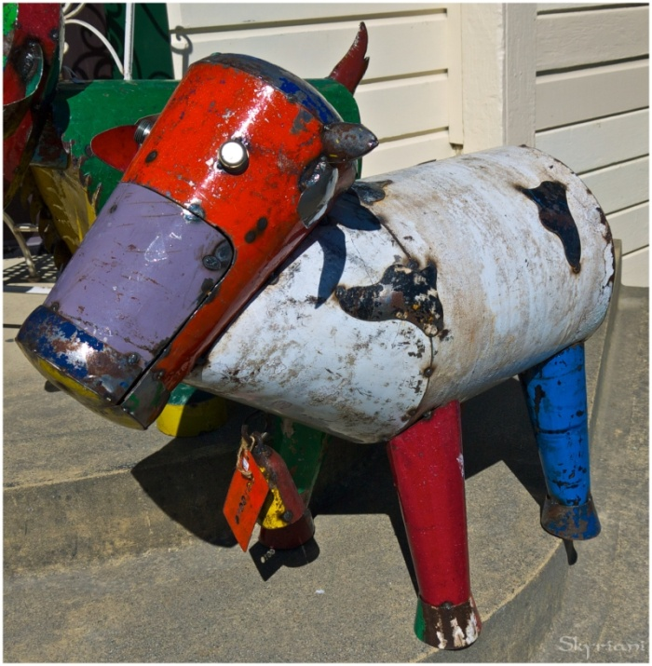

Self-Assessment
Was your letterbox and stand successful?
Explain your answer.

Did your research and planning help you in your design and ability to make your letterbox and stand?

Did you experience any difficulties in making the letterbox and stand?

If you were able to do this project again, what would you do differently and why?

Circle a number to show how you feel about the completed object you made.

1 2 3 4 5 6 7 8 9 10
Cold Warm Sizzling

Ag Day Marking Rubric
 | 1 | 2 | 3 | 4
RESEARCH | There is some evidence of research. | The research explains what materials are to be used. | The research explains what materials, equipment and tools are to be used. | The research explains what materials, equipment and tools are to be used.  The research is extensive and several different sources are cited.
DESIGN | Design sheet has some sections completed briefly. | Design sheet has most sections completed. | Design sheet has each section completed with some detail | Design sheet has each section completed fully and in detail.
LETTERBOX AND STAND | An attempt has been made to make a letterbox and stand out of durable materials. | The letterbox and stand is completed and is made of durable materials. Relates to a Kiwiana icon. | The letterbox and stand is completed and is made of durable materials. It is aesthetically pleasing and relates to a Kiwiana icon. | The letterbox and stand is completed and is made of durable materials. It is aesthetically pleasing and represents a Kiwiana icon.
ORIGINALITY AND INNOVATION | The design, letterbox and stand has been done lots of times before by other people | The design, letterbox and stand demonstrates some original ideas and some innovative use of materials. | The design, letterbox and stand demonstrates original ideas and innovative use of materials. | The design, letterbox and stand demonstrates highly original ideas and very innovative use of materials.
SELF ASSESSMENT | Self-assessment explains why the letterbox and stand was successful. | Self-assessment explains why the letterbox and stand was successful and what was difficult. | Self-assessment explains why the letterbox and stand was successful and what was difficult.  It explains how you could make it better next time. | Self-assessment explains why the letterbox and stand was successful and what was difficult.  It explains how you could make it better next time and how your planning helped your ability to design and make the object.

Timeline for Ag Day Project Years 4-6
Term 3
Week 7  Monday 2^{7th} August | Project requirements given out after explanation.
Week 8  Friday 7th September | Research outline sheet to be completed and checked by the classroom teacher.
Week 9  Friday 14th September | Design sheet to be completed and checked by the classroom teacher.
Week 10  Thursday 2^{0th} September | Final progress check by classroom teacher
Week 11  Wednesday 26th September | All written work, letterbox and stand to be completed, delivered and set up in the hall.

DO NOT name any work as you will be given a number as you take it into the hall for marking.

All marked projects will be on display in the hall on Saturday 29th September

Good luck to all pupils.

